Step 1: Download the email plugin

Step 2: Manage Jenkins 🡪 configure System

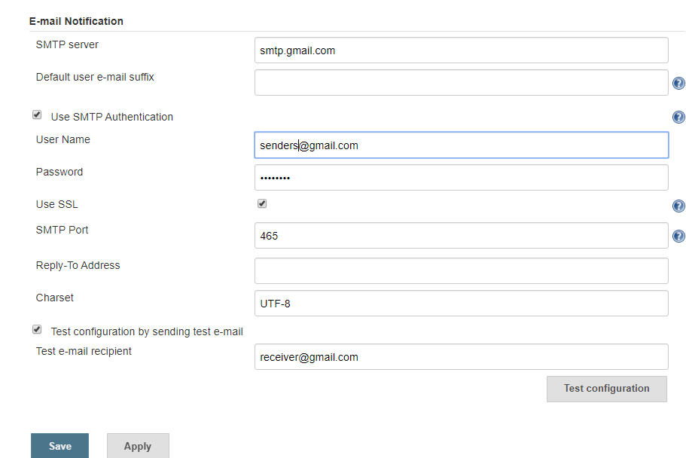

Test email must be successfully sent.

Step 3:

Sign into your google account -🡪 select signing into google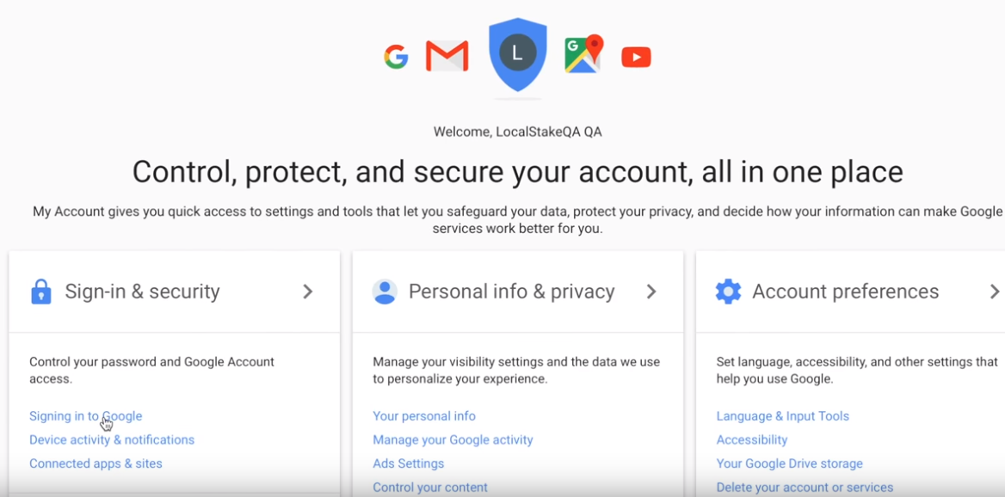

Also check Allow less secure apps on

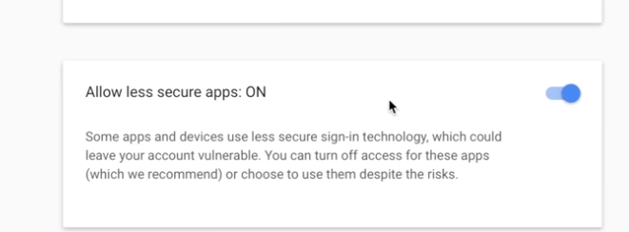

Step 4:

